# Information Visualization

# CHECKPOINT IV: First Prototype

G13-A

1. **Layout**

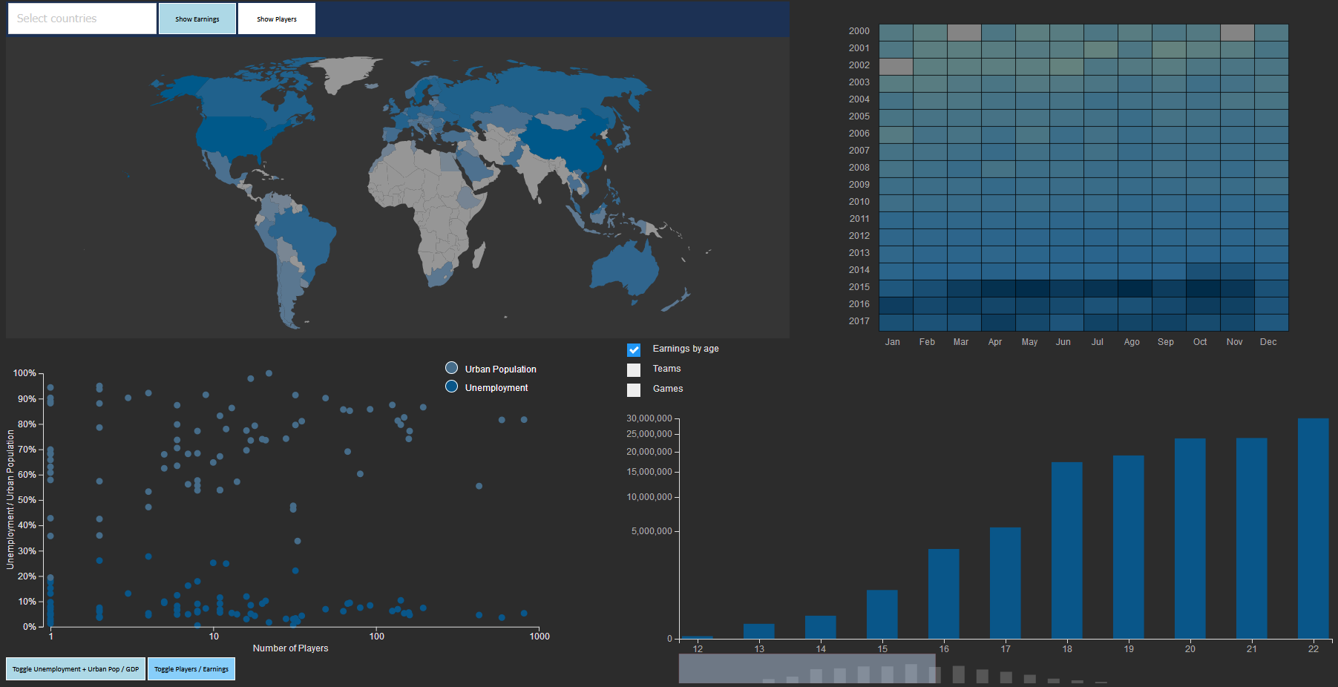

The visualization has a chloropleth map, a heatmap, a scatter plot and a bar chart.

The **chloropleth map** displays the earnings or the amount of players for each country, depending on what is selected.

The **scatter plot** displays earnings or players for each country, and urban population/ unemployment or GDP of each country.

The **heatmap** displays the amount of tournaments played in each month of a year.

The **bar chart** can display players earnings organised by age, the teams with highest earnings or most tournaments played, or the games with the highest sum of prize pools.

**2. Implemented Idioms**

* **Cloropleth map**:By default, the map displays the earnings per country, in a logarithmic colour scale from **#969696** to **#28638C**. If the “Show players” button is pressed, the map changes to display the amount of players on a linear color scale from **#677D91** to **#28638C**.

There’s also a dropdown menu where one can select a specific country. The functionality is the same as clicking on the country in the map: It highlights the country and filters the **scatter plot** by decreasing the radius of every country that isn’t selected.

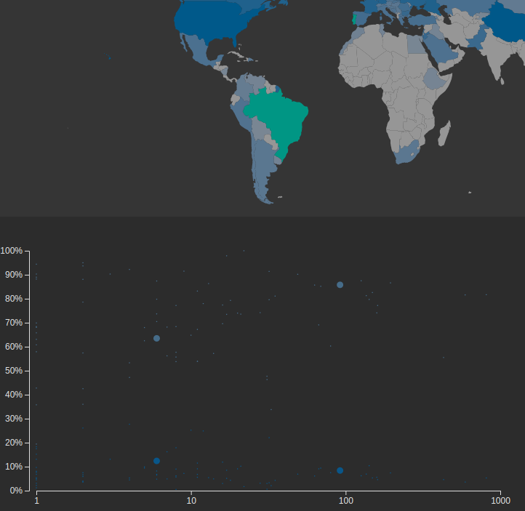

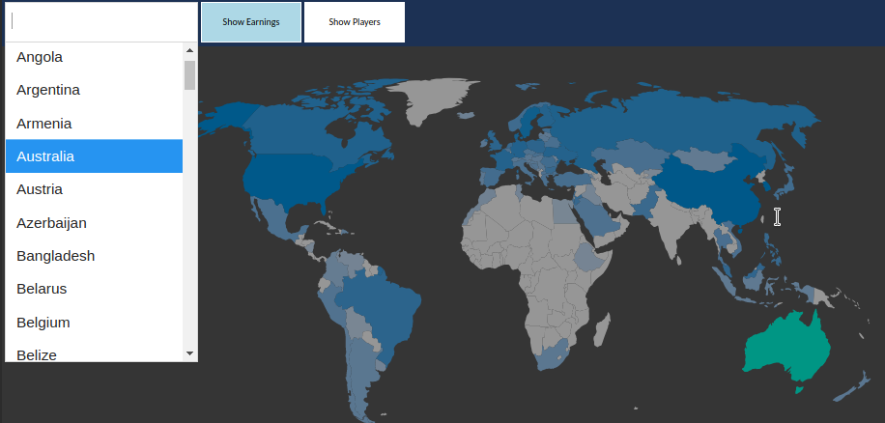

* **Scatter plot**: By default, the scatter plot displays the amount of players on a country on the X axis, and both urban population (lighter blue, **#466C89**), and unemployment (darker blue, **#095689**) on Y. The axes can be changed independently of each other: one can change the Y axis to only show GDP (turquoise, **#009684**), or change the X axis to show earnings instead of players.

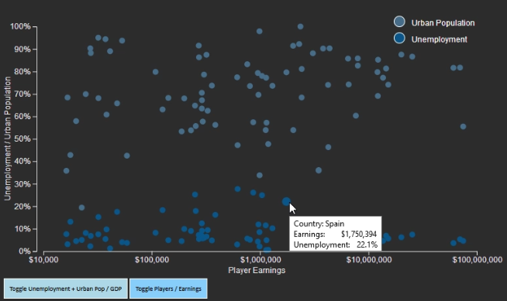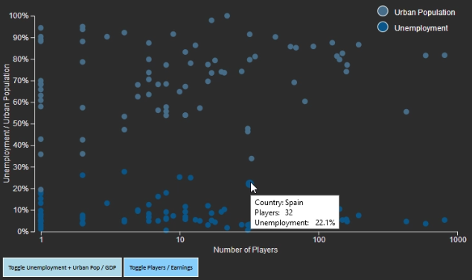

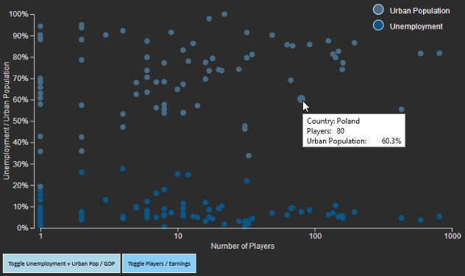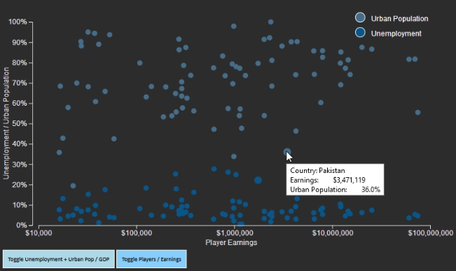

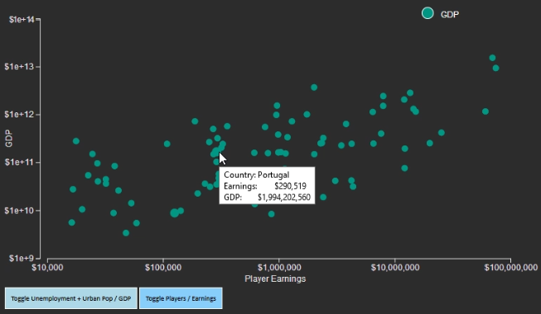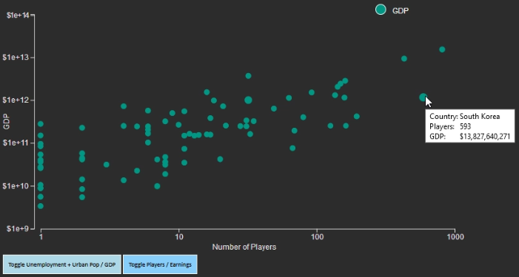

* **Heatmap**: the heatmap displays the amount of tournaments that occurred in a specific month (X axis) and year (Y axis), following a logarithmic colour scale ranging from **#64827e** to **#28638c** to **#002a47**. Clicking on a specific rectangle in the heatmap changes the bar chart to display the teams that won tournaments in that month, and how many they won.

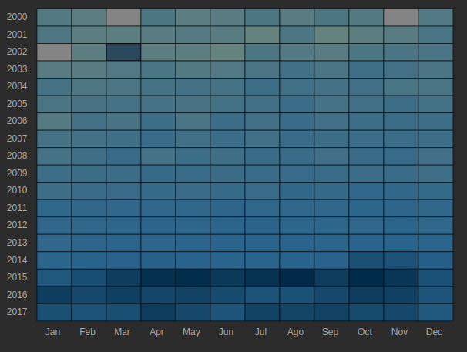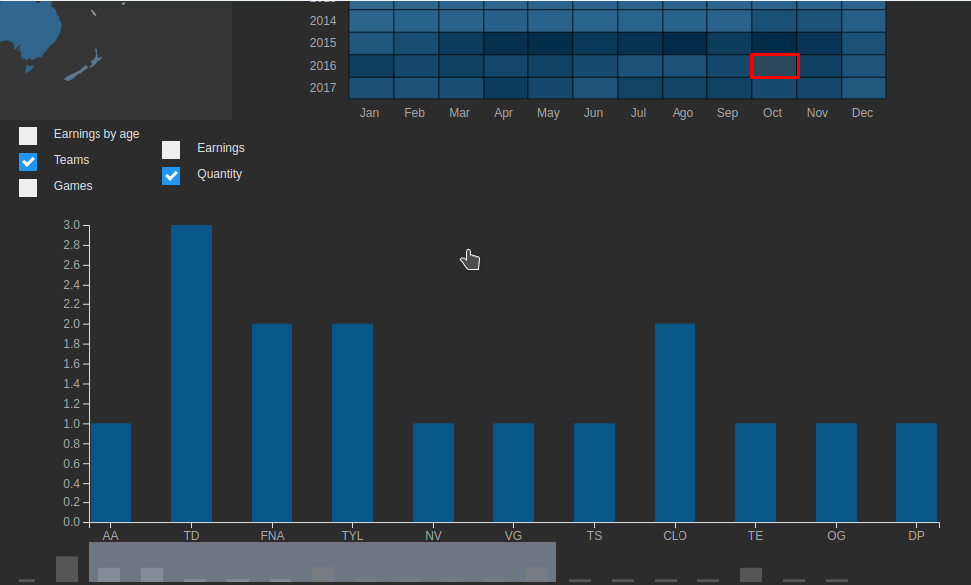

* **Bar chart**: By default, the bar chart displays players earnings by age. A **power scale** with a reduced exponential is used to show a larger bar for smaller values while retaining enough visual clarity to compare the larger values. It’s also possible to click on different checkbox buttons to show team earnings, tournaments won by team, total prize pool sum by game, and tournaments played by game. All of these use the same **power scale** for the aforementioned reason (a logarithmic scale could also be used, but it makes bigger values too similar to be visually clear). While not every bar is displayed on screen (there’s hundreds of games and thousands of teams), a small scroll bar sits below the chart, showing the entire set of bars in a smaller format and allowing scrolling through the main bar chart.

